Classical Mechanics
Introduction
Saved 2022-02-20

Contents
1 Overview 3
1.1 Applicability 3
1.2 Historical Perspective 4
1.3 Branches of Classical Mechanics 5
2 Newton's Mechanics 6
2.1 Center of Gravity 6
2.2 Mass, Space and Time 7
2.3 Velocity and Acceleration 7
2.4 Newton's Laws 7
2.5 Fundamental Principles 7
2.6 Statics 7
2.7 Geometry of Masses 7
2.8 Kinematics of Rigid Bodies 7
2.9 Motion in one dimension 7
2.10 Motion in three dimensions 7
2.11 Newton's Laws of Motion 7
2.12 Conservation of Energy 7
2.13 Conservation of Momentum 7
2.14 Circular Motion 8
2.15 Rotational Motion 8
2.16 Angular Momentum 8
2.17 Orbital Motion 8
2.18 Oscillatory Motion 8
2.19 Wave Motion 8
2.20 Composite Motion 8
2.21 Kinematics of Deformable Bodies 8
2.22 Fluid Mechanics 8
3 Lagrangian Formalism 9
4 Hamiltonian Formalism 10
References 11

Overview
Classical Mechanics is a branch of physics. Just like all other theories in physics, classical mechanics provides mathematical models.

Classical mechanics is a theory about the motion and interaction of objects.

Just like all other theories in physics, classical mechanics is not always applicable. Its applicability comes with constraints.

Applicability
Classical mechanics is quite useful in everyday life, where we deal with objects that are not too small, and, which are not moving too fast. These were the constraints.

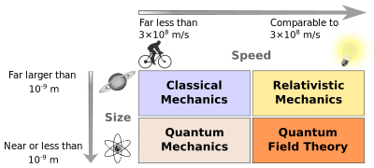
Figure 1 - Applicability of classical mechanics and other theories

By "not too small", I mean objects that are visible with the naked eye; the so called macroscopic objects. Particle Physics and Quantum Physics deal with "too small" objects, which are also called microscopic objects.

By "not too fast", I mean objects that are moving much slower than the speed of light. Okay, great. Much slower? How much slower? Well, pretty much slower.

Thing is, that a small Jew (not that one who wrote the Bible, another one, named Albert Einstein) came up with the Theory of Relativity fundamentally revising Newton's Classical Mechanics. He shows that multiple entities within classical mechanics that are considered constant, such as mass, time, distance, are in fact not constant, but they are a function of speed. The faster an object moves, the smaller it gets. Its mass increases, and its time slows down relative to the time of other objects that travel slower. The faster an object travels the more significant these relativistic effects become. For motions pretty much slower than light, the relativistic effects are considered negligible. There is no hard boundary for the exact speed beyond which classical mechanics becomes wrong. It's all about accuracy. One thing is sure, that near the speed of light the formulas of classical mechanics become quite useless.

In this document we'll consider classical mechanics. While there are more accurate physical theories that describe objects in motion, and their interactions, Newton's mechanics remains quite good for most applications in everyday life. Generalizations of Newton's mechanics are Lagrangian mechanics and Hamiltonian mechanics, and ultimately the theory of relativity.

Historical Perspective

1800BC
- The first known functional theory on planets.
- "The Venus tablet of Ammisaduqa" – records the movement of Venus for a period of 21 years.

400BC
- Babylonian astronomers calculate the distance to Jupiter.

- The book titled "Lectures on Nature" (Φυσικὴ ἀκρόασις)
by Aristotle (Ἀριστοτέλης) (384-322BC)

- First known heliocentric model
by Aristarchus of Samos (Ἀρίσταρχος ὁ Σάμιος) (310-230BC)

- The manuscript titled "On the Sizes and Distances of the Sun and Moon" (Περὶ μεγεθῶν καὶ ἀποστημάτων ἡλίου καὶ σελήνης)
by Aristarchus of Samos (Ἀρίσταρχος ὁ Σάμιος) (310-230BC)

300BC
- Center of gravity, principle of buoyancy, principle of the lever
by Aristotle

10AD
- The manuscripts titled "Mechanics" (Μηχανική), "Pneumatics" (Πνευματικά), "Automata" (descriptions of automatic hydraulic door openers/closers, statues that pour wine, etc.), "Catoptrica" (optics and usage of mirrors), "Belopoeica" (description of war machines)
by Heron of Alexandria (Ἥρων ὁ Ἀλεξανδρεύς) (10-70AD)

- The first steam engine, the aeolipyle (αιολουπυλη), the first windmill, and the "dioptra" (διόπτρα), the precursor of the telescope.
by Heron of Alexandria

350AD
- The concept of friction.
by Thermistius (Θεμίστιος Εὐφραδής) (317-388AD)

500AD
- The concept of inertia. Statement about the equivalence of gravitational and inertial mass.
by John Philoponus (Ἰωάννης ὁ Φιλόπονος) (490-570AD)

1000AD
- The first use of three orthogonal coordinates to describe a point in space. The introduction of the scientific method in mechanics. Accurate calculation of Earth's radius.
by Abu Rayhan al-Biruni (ابوریحان محمد بن احمد بیرونی) (973-1048AD)

1100AD
- The concept of force.
By Abu Bakr ibn Bajja (أبو بكر محمد بن يحيى بن الصائغ التجيبي بن باجة) (1085-1138AD)

1300AD
- The theory of impetus, the precursor of inertia, momentum, and acceleration in classical mechanics.
by Jean Buridan (1301-1362AD)

1400AD
- The mean speed theorem.

1500AD
- Earth rotation explained with "circular inertia".
by Abd Ali Birjandi (عبدعلی محمد بن حسین بیرجندی) (?-1528AD)

- Proof that different weights fall with the same acceleration. (1589AD)
by Galileo Galilei

1600AD
- The first book on kinematics and material science titled "Discourses and Mathematical Demonstrations Relating to Two New Sciences" (Discorsi e dimostrazioni matematiche intorno a due nuove scienze)
by Galileo Galilei

- The first formulations of the principles of conservation of momentum and conservation of energy.
by René Descartes, John Wallis, and Gottfried Leibniz.

- Discovery of the Coriolis effect.
by Giovanni Battista Riccioli and Francesco Maria Grimaldi

- The law of inertia (Newton's first law).
by Baruch Spinoza.

- The laws of planetary motion. Precursor of Newton's Law of Universal Gravitation.
by Johannes Kepler.

- Newton's Laws of Motion and Newton's Law of Universal Gravitation.
by Isaac Newton (1642-1726AD)

Branches of Classical Mechanics

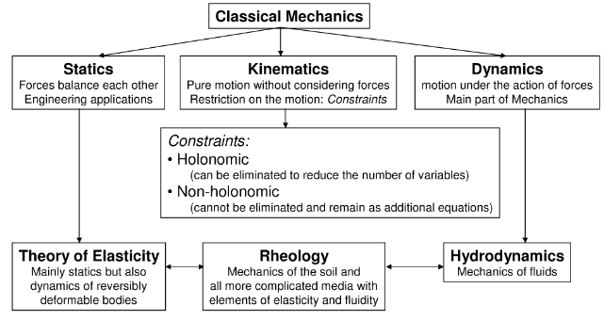
Figure 2 - Branches of Classical Mechanics

Newton's Mechanics

Newton's mechanics allows us to describe and predict the conditions of movement of bodies subjected to forces.

Center of Gravity
Let's start simple. Objects in our mathematical model we're going to develop are represented by their center of gravity. According to NASA, the center of gravity is a geometric property of any object:

"The center of gravity is a geometric property of any object. The center of gravity is the average location of the weight of an object. We can completely describe the motion of any object through space in terms of the translation of the center of gravity of the object from one place to another and the rotation of the object about its center of gravity if it is free to rotate. If the object is confined to rotate about some other point, like a hinge, we can still describe its motion."

OK, fine. How we find the center of gravity of any object? Well, it's simple:

- Step 1: Hang the object from any point and drop a weighted string from the same point. Draw a line on the object along the string.

- Step 2: Repeat the procedure from another point. The center of gravity is the point where the lines intersect.

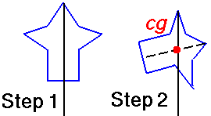
Figure 3 - Center of gravity of a general shape

For simple geometric shapes we can actually determine the center of gravity with some drawing. For example, the center of gravity of a triangle can be found by drawing a line from one of its vertices to the middle of the opposing edge, then repeating the procedure with another vertex and the corresponding opposing edge:

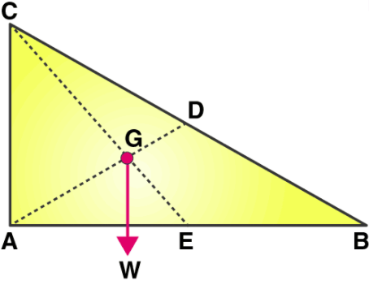
Figure 4 - Center of gravity of a triangle

This procedure works well for any irregularly shaped object, but it assumes the mass of the object is uniformly distributed within the object. On such objects the center of mass and the center of gravity coincide. The procedure described above also assumes that the object is two-dimensional.

Mass, Space and Time

Velocity and Acceleration

Newton's Laws

Fundamental Principles

Statics

Geometry of Masses

Kinematics of Rigid Bodies

Motion in one dimension

Motion in three dimensions

Newton's Laws of Motion

Conservation of Energy

Conservation of Momentum

Circular Motion

Rotational Motion

Angular Momentum

Orbital Motion

Oscillatory Motion

Wave Motion

Composite Motion

Kinematics of Deformable Bodies

Fluid Mechanics

Lagrangian Formalism

Hamiltonian Formalism

References
[1]

There are certainly more accurate definitions for how small an object should be to be considered too small to consider, but let's stick with this definition for now.
The noun "physics" comes from the Greek word "φυσικό", meaning "natural".
The mean radius of the Earth was 6339.6 kilometers according to al-Biruni. The modern mean value is 6371.0 kilometers.
If the mass is not uniformly distributed, then we must use calculus to determine the center of gravity. We'll consider that later.
For three-dimensional objects the same method can be applied, but you may have to hang the object more than twice in order to be able to calculate the exact position of the center of gravity, since the center of gravity will most probably located inside the object.

